Access, Materials Handling
Elevating work platforms
Course Objective:
Our 8-hour, one day training course is designed for people who need an alternative to working from ladders. It’s an introductory training course, with preference for hands on time spent understanding how to correctly operate the equipment.
A 4-hour theory presentation focuses on generic safe operating procedures and risk assessment. An introduction to harnesses is included.
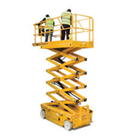
This course can be customised for operators of different EWP types, specific workplaces and industry production activities.
Course Outcome:
On successful completion students will be issued with a Statement of training card and log book for assessment preparation in accordance with RIIHAN301D Operate elevating work platforms.
In line with Industry expectations, a short harness awareness presentation is included.

Course Content:

Planning and preparing for EWP operations
- Operating the EWP safely
- Start up and shut down procedures
- Safe movement
- Relocating the machine
- Carrying out machine operator maintenance

Assessment:
- Theory Assessment (open book)
- Practical Assessments (progressive activities)

Training and Assessment:

1 day program (depending on experience)
- Declaration of previous experience may be presented.

Times:
- 0800 to 1600

Course Prerequisites:
- Students must be able to access the equipment.
- Ability to use and understand basic English
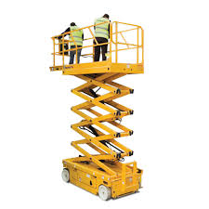

RTO 0581 Carlisle Learning and Development Pty Ltd.

Fee Includes:
- Learning Materials
- Assessment

Cost:
Refer to training program

Course Location:
- At our training facilities, located at Mount Barker and Dawesley
- On-site training is available.

Personal Protective Equipment:
Students are required to wear work boots with a nonslip sole, long sleeve shirt, trousers, Hi vis vests to be worn during practical exercises.

Students must present Photo Identification ie Australian Drivers Licence, Passport or Proof of Age card in addition to a USI (Unique Student Identifier)

V20180913

20 Oborn Road Mount Barker SA 5251
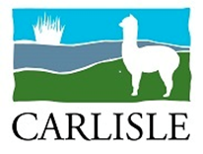
Telephone: 08 8391 5912
AH: 0422 827 602 or 0428151366
Email: education@carlislelodge.com.au
www:carlislelodge.com.au
www.carlislelearning.com.au

RIIHAN301D Operate Elevating Work Platform

Application
This unit describes a participant’s skills and knowledge required to operate an elevating work platform in the Resources and Infrastructure Industries.
This unit is appropriate for those working in operational roles.
Licensing, legislative, regulatory and certification requirements that apply to this unit can vary between states, territories and Industry sectors. Relevant information must be sourced prior to application of the unit.

Elements and Performance Criteria
1. Plan and prepare for operating an elevating work platform | 1.1 Access, interpret and apply elevating work platforms documentation and ensure the work activity is compliant  1.2 Obtain, read, interpret, clarify and confirm work requirements  1.3 Select and wear personal protective equipment appropriate for work activities  1.4 Identify and select any required tools and equipment, check for serviceability and rectify or report, verbally or in writing, any faults prior to commencement  1.5 Perform pre-start and post-start inspections/checks  1.6 Coordinate activities with others prior to commencement of, and during, the work activity  1.7 Identify and address potential risks, hazards and environmental issues, and implement control measures  1.8 Obtain and interpret emergency procedures, and be prepared for fire/accident/emergency
2. Conduct work activities from elevating work platform | 2.1 Stabilise elevating work platform  2.2 Place tools and equipment into bucket/platform  2.3 Use approved safety devices, ensure safety of personnel and surrounding site  2.4 Act on or report, verbally or in writing, monitoring systems and alarms  2.5 Recognise and respond to hazardous and emergency situations  2.6 Complete work and shut-down in accordance with agreed work plan
3. Carry out operator maintenance | 3.1 Carry out work platform inspections and fault finding  3.2 Carry out routine operational servicing, lubrication and housekeeping tasks in accordance with manufacturer's instructions and site authorised procedures and practices  3.3 Carry out minor operator maintenance to manufacturer's instructions and site requirements  3.4 Process written records
4. Clean up | 4.1 Clear work area and reuse, recycle or dispose of materials  4.2 Check, clean, maintain and store plant, tools and equipment

