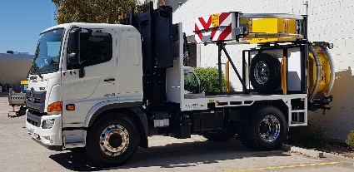
Attenuator operator training.(1 day)
Control traffic with a stop-slow bat, Implement traffic management plan.
2 day (WZTM)
Course Objective:
Our two day training course is designed for people who need to work semi – autonomously in a team environment. It’s an introductory training course for inexperienced persons, with risk management techniques explained.
Refresher training is available as a 1 day course for not yet expired card holders.

Course Outcome:
On successful completion students will be issued with a Statement of attainment with RIIWHS205E Control traffic with a stop-slow bat, and RIIWHS302E Implement traffic management plan.
The SA Department of Infrastructure and Transport card is usually available within 14 days.

Course Content:

Plan and prepare
- Control traffic
- Operate communication devices
- Set out, monitor and close down traffic guidance scheme

Assessment:
- Theory Assessment (open book)
- Practical Assessments (progressive activities)

Training and Assessment:

2 day training program
- Several activities will be required.

Times:
- Start time 0800
- Usually scheduled fortnightly

Course Prerequisites:
- Ability to read and understand basic English
- Communicate effectively with English language

RTO 0581 Carlisle Learning and Development Pty Ltd.

Heavy Equipment Training and Assessment P/L

Fee Includes:
- Learning Materials
- Assessment

Cost:
2 day $550
Refresher $300
Attenuator $750

Course Location:
- At our training facilities, located at Mount Barker and Dawesley
- On-site training is available.

Personal Protective Equipment:
Students are required to wear covered toe shoes or work boots, long sleeve shirt, trousers and sun protection for outside activities, Hi vis vests to be worn during practical exercises.

Students must present Photo Identification ie Australian Drivers Licence, Passport or Proof of Age card in addition to a USI (Unique Student Identifier)

V20210628

20 Oborn Road Mount Barker SA 5251
Telephone: 08 8391 5912 or 8398 5468
AH: 0422 827 602 or 0428 151 366
Email: education@carlislelodge.com.au
www.carlislelearning.com.au

Other related courses

CPCCWHS1001 Prepare to work safely in the construction industry.

(usually referred to as “white card”)

RIIWHS201E Work safely and follow WHS policies and procedures.

RIICOM201 Communicate in the workplace

RIIRIS301E Apply risk management processes.

RIIRTM301E Operate a truck or trailer mount attenuator

