Farmers Guide to WHS series
Plant and Machinery
Operate Tractors
Course Objective:
Our 12 hour, two day training course is designed for people who have little tractor operating experience. It’s an introductory training course, with preference for hands on time spent understanding how to correctly operate the equipment.
A 4 hour evening theory presentation focuses on generic safe operating procedures and risk assessment.
This course can be customised for operators of different tractor types, specific attachments and agrifood production activities on your property with your equipment.

Course Outcome:
On successful theory completion students will be issued with a Statement of training enrolment card and log book for recording experience, ready for assessment preparation in accordance with AHCMOM202 Operate tractors, or RIIMPO315D Conduct Tractor Operations.

Course Content:

Planning and preparing for tractor operations
- Operating the tractor safely
- Start up and shut down procedures
- Select, remove and fit attachments
- Relocating the machine
- Carrying out machine operator maintenance

Assessment:
- Theory Assessment (open book)
- Practical Assessments (progressive activities)

Training and Assessment:

2 day program (depending on experience)
- Declaration of previous experience should be presented.

Times:
- As required

Course Prerequisites:
- Students must be eligible for licensing.
- Ability to use and understand basic English

RTO 0581 Carlisle Learning and Development Pty Ltd.

Fee Includes:
- Learning Materials
- Assessment
- Card issue

Cost:
Refer to training schedule
Employer On farm courses day rate negotiable.

Course Location:
- At our training facilities, located at Mount Barker (theory) and Dawesley (field training)
- On-site training and assessment is available.

Personal Protective Equipment:
Students are requested to wear work boots with a nonslip sole, long sleeve shirt, trousers, Hi-vis vests to be worn by groups during practical exercises.

Students must present Photo Identification eg. Australian Drivers Licence, Passport or Proof of Age card in addition to a USI (Unique Student Identifier)

VJD20180913

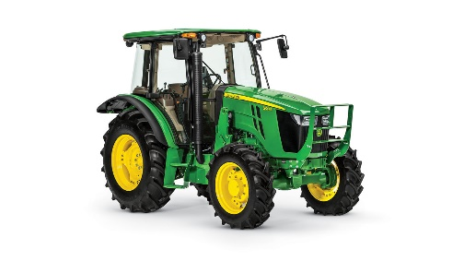
20 Oborn Road Mount Barker SA 5251
Telephone: 08 8391 5912
AH: 0422 827 602 or 0428151366
Email: education@carlislelodge.com.au
www:carlislelodge.com.au
www.carlislelearning.com.au

RIIMPO315D Conduct tractor operations

Application
This unit of competency describes the skills and knowledge required to operate tractors with and without attached equipment.
All work must be carried out to comply with workplace procedures, work health and safety requirements, manufacturer’s specifications and sustainability practices.

Range of Conditions
An induction process for the use of the tractor must be followed, including reading and observing the manufacturer’s manual when using a different tractor or on a different property.
Assessments must be conducted on candidates performing a range of activities, using a range of attachments and implements, in a range of surface and terrain conditions.

Elements and Performance Criteria
1. Plan and prepare for tractor operations | 1.1 Access, interpret and apply tractor operations documentation and ensure the work activity is compliant  1.2 Obtain, read, interpret, clarify and confirm work instructions  1.3 Identify and address risks, hazards and environmental issues and implement control measures  1.4 Select and wear personal protective equipment appropriate for work activities  1.5 Identify, obtain and implement traffic management signage requirements  1.6 Select, and check for faults, equipment and/or attachments for work activities  1.7 Obtain and interpret emergency procedures, and be prepared for fire/accident/emergency
2. Operate tractor | 2.1 Carry out pre-start, start-up, park, shutdown and secure equipment procedures  2.2 Coordinate activities with others at the site prior to commencement of, and during, the work activity  2.3 Drive and operate tractor, and modify the operating technique to meet changing work conditions  2.4 Complete work plan within the operating capacity of the equipment  2.5 Act on or report monitoring systems and alarms  2.6 Continually monitor hazards and risks, and ensure safety of self, other personnel, plant and equipment
3. Select, remove and fit attachments | 3.1 Select attachment for the task  3.2 Remove and fit attachment  3.3 Test attachment to ensure correct fitting and operation  3.4 Use attachment in accordance with recommendations and design limits  3.5 Clean and store removed attachments in designated location
4. Relocate tractor | 4.1 Prepare tractor for relocation  4.2 Move tractor safely between worksites, observing relevant codes and traffic management requirements
5. Carry out machine operator maintenance | 5.1 Prepare machine for maintenance  5.2 Conduct inspection and fault finding  5.3 Carry out scheduled maintenance tasks  5.4 Process written maintenance records
6. Conduct housekeeping activities | 6.1 Clear work area and dispose of or recycle materials  6.2 Process records

