Plant and Machinery Operation
Work Platform Licensing (high risk)
TLILIC0005
Course Objective:
Our training program is designed upgrade experienced EWP operators who wish to operate higher lift machines. It’s a high risk license introductory training course, with preference for hands on time spent understanding how to correctly operate the equipment.
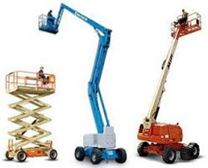
This course can be customised for operators of different WP types, specific features and industry production activities.
On successful completion students will be issued with a Statement of satisfactory assessment in accordance with TLILIC0005 License to operate a boom type elevating work platform (boom length 11 metres or more).
After successful final assessment, operators will be able to apply for issue of a high risk license.

Course Content:

Planning and preparing for work platform operations
- Operating the work platform safely
- Start up and shut down procedures
- Carrying out machine operator maintenance

Assessment:
- Theory Assessment (closed book)
- Practical Assessments (progressive activities)

Training and Assessment:

Up to 3 day program (depending on experience)
- Declaration of previous experience should be presented.

Times:
- 0800 to 1630 each day if required.

Course Prerequisites:
- Students must be eligible for licensing.
- Ability to use and understand basic English
- 18 years of age for assessment.
- RIIWHS204E Work safely at heights
- RIIHAN301E Operate an elevating work platform
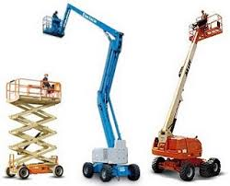

RTO 0581 Carlisle Learning and Development Pty Ltd.

Heavy Equipment Training and Assessment P/L

Fee Includes:
- Learning Materials
- Initial Assessment

Cost: $650 per person

Course Location:
- At our training facilities, located at Mount Barker
- On-site training is available.

Personal Protective Equipment:
Students are required to wear work boots with a nonslip sole, long sleeve shirt, trousers, Hi-vis vests to be worn during practical exercises. (supplied)

Students must present Photo Identification ie Australian Drivers Licence, Passport or Proof of Age card in addition to a USI (Unique Student Identifier)

V20210629

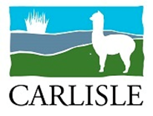
20 Oborn Road Mount Barker SA 5251
Telephone: 08 8391 5912, 8398 5468
AH: 0422 827 602 or 0428151366
Email: education@carlislelodge.com.au
www.carlislelearning.com.au

Carlisle Learning and Development Pty Ltd RTO 0581
A responsible, Duty of Care approach to training.
Options available to customise your learning experience to suit your needs:

(We are able to arrange Forklift training for several levels of trainee experience.)

Preparation Course One or two day familiarisation options:
Inexperienced or new operators ; RIIHAN301E Operate an EWP ($280)
RIIWHS204E Work safely at heights ($300) or combi 1 Day $500
On enrolment students undertake training, involving Work platform safety theory, basic operating instructions and coaching to a stage where they are “safe” operators. Trainees also need to be aware of fall prevention in a workplace environment , involving PPE inspection, fitment and adjustment of harnesses and components utilised. This can usually be achieved in a single day, and is an excellent preparation for the licensing course. Workplace development continues until ready for a licence assessment.

High Risk Work Platform (WP) Licence Assessment
Experienced operators
TLILIC0005 Licence to Operate a boom type elevating work platform (boom length 11 metres or more) 2 Day $650

Students wanting the Nationally Accredited High Risk Licence will need to enrol with an RTO, participate in a theory instruction and test, and demonstrate their competence to an RTO assessor approved by the Regulator (SafeworkSA) on several occasions. (The evidence requirements are quite strict). The first day is training, and the second assessments. Further coaching may be required before the assessment is attempted.. The preparation course is highly recommended for students with no prior learning on boom lifts, as the license theory test is intensive.
- Completion statement of attainment included.
- High risk license issued by Government Agency.

Existing High Risk Licence Holder refresher.
VOC (Verification of Competency) 2 hours, $400

If a refresher is needed, we can arrange it at fairly short notice. An RPL approach is usually applied. These are often referred to as VOC’s (verification of competency), and are often requested by an employer when there has been a gap in experience, or no recent industry evidence. A training card is issued to reflect the most recent assessment, but this does not replace the high risk license.

- Licenses can only be issued, or re-issued by the Regulator (SafeworkSA).

V20210629 https://www.safework.sa.gov.au/__data/assets/pdf_file/0019/183016/Mobile-elevating-work-platforms-guideline.pdf

