Plant and Machinery Operation
Forklift Licensing (high risk)
TLILIC0003
Course Objective:
Our training program is designed for both experienced or people who have little forklift operating experience. It’s a high risk license introductory training course, with preference for hands on time spent understanding how to correctly operate the equipment.
This course can be customised for operators of different forklift types, specific attachments and industry production activities.
On successful completion students will be issued with a Statement of satisfactory assessment in accordance with TLILIC0003 License to operate a forklift.
After successful final assessment, operators will be able to apply for issue of a high risk license.

Course Content:

Planning and preparing for forklift operations
- Operating the forklift safely
- Start up and shut down procedures
- Select, lift and place loads safely.
- Relocating the machine
- Carrying out machine operator maintenance

Assessment:
- Theory Assessment (closed book)
- Practical Assessments (progressive activities)

Training and Assessment:

Up to 3 day program (depending on experience)
- Declaration of previous experience should be presented.

Times:
- 0800 to 1630 each day if required.

Course Prerequisites:
- Students must be eligible for licensing.
- Ability to use and understand basic English
- 18 years of age for assessment.
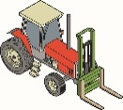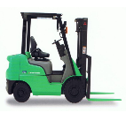

RTO 0581 Carlisle Learning and Development Pty Ltd.

Heavy Equipment Training and Assessment P/L

Fee Includes:
- Learning Materials
- Initial Assessment

Cost: $500 per person

Course Location:
- At our training facilities, located at Mount Barker
- On-site training is available.

Personal Protective Equipment:
Students are required to wear work boots with a nonslip sole, long sleeve shirt, trousers, Hi-vis vests to be worn during practical exercises. (supplied)

Students must present Photo Identification ie Australian Drivers Licence, Passport or Proof of Age card in addition to a USI (Unique Student Identifier)

V20210629

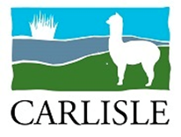
20 Oborn Road Mount Barker SA 5251
Telephone: 08 8391 5912, 8398 5468
AH: 0422 827 602 or 0428151366
Email: education@carlislelodge.com.au
www.carlislelearning.com.au

Carlisle Learning and Development Pty Ltd RTO 0581
A responsible, Duty of Care approach to training.
Options available to customise your learning experience to suit your needs:

(We are able to arrange Forklift training for several levels of trainee experience.)

Preparation Course One or two day options:
Inexperienced or new operators ; Forklift operational awareness: 1 Day $200

On enrolment students undertake training, involving Forklift safety theory, basic operating instructions and coaching to a stage where they are “safe” operators, ready to continue training in a workplace environment under supervision of a high risk licensed operator. This is often referred to as a “Duty of Care or training” ticket, and accepted by most employers. Provisos for log book work under supervision is that the person is enrolled with an RTO and has received training. This can usually be achieved in a single day, and is an excellent preparation for the licensing course. Workplace development continues until ready for a licence assessment.
- Log book and training card (included)

High Risk Forklift (LF) Licence Assessment
Experienced operators
TLILIC0003 Licence to Operate a Forklift truck 2 Day $500

Students wanting the Nationally Accredited High Risk Licence will need to enrol with an RTO, participate in a theory instruction and test, and demonstrate their competence to an RTO assessor approved by the Regulator (SafeworkSA) on several occasions. (The evidence requirements are quite strict). The first day is training, and the second assessments. Further coaching may be required before the assessment is attempted.. The preparation course is highly recommended for students with no prior learning on forklift, as the license theory test is intensive.
- Completion statement of attainment included.
- High risk license issued by Government Agency.

Existing High Risk Licence Holder refresher.
VOC (Verification of Competency) 2 hours, $300

If a refresher is needed, we can arrange it at fairly short notice. An RPL approach is usually applied. These are often referred to as VOC’s (verification of competency), and are often requested by an employer when there has been a gap in experience, or no recent industry evidence. A training card is issued to reflect the most recent assessment, but this does not replace the high risk license.

- Licenses can only be issued, or re-issued by the Regulator (SafeworkSA).

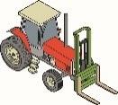
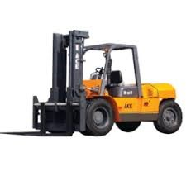
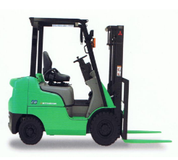
V20210629

