Operate Excavator (RIIMPO301E)
Civil Construction excavator RIIMPO320F
Course Objective:
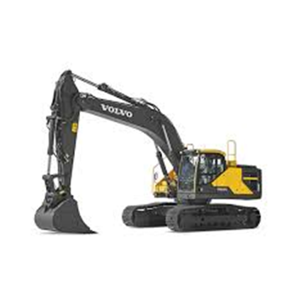
Our two day training course is designed for people who have little Excavator operating experience. It’s an introductory training course, with preference for hands on time spent understanding how to correctly operate the equipment.
A 4 hour theory presentation focuses on generic safe operating procedures and risk assessment. Pre course study is recommended.
This course can be customised for operators of different Excavator types, specific boom attachments and agrifood production activities.
Course Outcome:
On successful completion students will be issued with RIIMPO301E Conduct Hydraulic Excavator operations, or
RIIMPO320F for Civil Construction.

Course Content:

Planning and preparing for Excavator operations
- Operating the Excavator safely
- Start up and shut down procedures
- Select, remove and fit attachments / buckets
- Relocating the machine
- Carrying out machine operator maintenance

Assessment:
- Theory Assessment (open book)
- Practical Assessments (progressive activities)

Training and Assessment:

1 to 5 day program (depending on experience)
- Declaration of previous experience should be presented.

Times:
- 0800 to 1600

Course Prerequisites:
- Students must be eligible for licensing.
- Ability to use and understand basic English
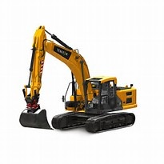

RTO 0581 Carlisle Learning and Development Pty Ltd.

Heavy Equipment Training and Assessing P/L

Fee Includes:
- Learning Materials
- Initial Assessment
- Training card

Cost: On application
See schedule for details
CITB rebate may apply

Course Location:
- At our training facilities, located at Mount Barker and Dawesley
- On-site training is available.

Personal Protective Equipment:
Students are required to wear work boots with a nonslip sole, long sleeve shirt, trousers, Hi vis vests to be worn during practical exercises.

Students must present Photo Identification ie Australian Drivers Licence, Passport or Proof of Age card in addition to a USI (Unique Student Identifier)

V20210629

20 Oborn Road Mount Barker SA 5251
Telephone: 08 8391 5912, 8398 5468
AH: 0422 827 602 or 0428151366
Email: education@carlislelodge.com.au
www.carlislelearning.com.au

